Food Delivery Order Trends and Customer Demand Insights
1. Abstract
Customer demand in food service is strongly influenced by convenience, service availability, and restaurant features that shape ordering behaviour. Food delivery patterns help explain how customer choices are influenced by service options, pricing, and restaurant features in urban dining environments. This project examines restaurant-related information to understand how factors such as online ordering availability, table booking options, ratings, customer votes, pricing estimates, and food categories are connected to customer demand. The analysis shows that restaurants offering online food delivery receive stronger customer response, with higher order preference and better vote counts when compared with offline-focused services or table booking options alone. It also highlights how customer interest varies across restaurant types and how pricing levels relate to ratings and popularity. By observing these trends, the project presents a clearer picture of service features that attract more customer engagement and influence food delivery demand. The findings help explain how convenience-based choices shape restaurant performance and customer preference in food service activity.

2. INTRODUCTION
The food service industry has undergone a major transformation over the past decade, driven largely by the growing demand for convenience and the rapid expansion of digital platforms. Urban lifestyles have become increasingly fast paced, leaving individuals with limited time for traditional dining experiences. As a result, food delivery services have emerged as an essential part of daily life, allowing customers to access a wide variety of cuisines from the comfort of their homes. Restaurants are no longer limited to physical dining spaces, as their reach now extends through digital ordering systems that connect them directly with customers. This shift has changed not only how food is consumed but also how businesses operate and compete within the market.
The growth of online food delivery services has introduced a new level of competition among restaurants. Customers are presented with numerous options, making their choices dependent on various factors such as ratings, pricing, delivery availability, and service features. Restaurants must now focus not only on food quality but also on how effectively they present themselves through digital platforms. Features such as online ordering and table booking play a significant role in influencing customer decisions. Understanding how these features impact demand is essential for restaurants aiming to attract and retain customers in a highly competitive environment.
One of the key challenges in this domain is understanding customer behavior in a data driven manner. Traditional methods of analyzing customer preferences often relied on limited observations or manual feedback, which may not provide a complete picture of demand patterns. With the availability of structured data related to restaurant services and customer interactions, it is now possible to analyze trends in a more systematic and detailed way. This allows for better insights into how different factors contribute to customer engagement and order frequency. By examining variables such as ratings, votes, cost estimates, and service options, it becomes possible to identify patterns that are not immediately visible through casual observation.
The importance of analyzing food delivery trends lies in its direct impact on business performance. Restaurants that understand customer preferences are better positioned to optimize their services, improve customer satisfaction, and increase revenue. For example, if data shows that online ordering significantly boosts customer engagement, restaurants can invest more in improving their delivery infrastructure. Similarly, understanding the relationship between pricing and customer ratings can help businesses set competitive prices that attract a larger audience without compromising profitability. These insights are crucial for making informed decisions that align with market demand.
Another important aspect of this problem is the diversity of restaurant types and customer preferences. Different types of restaurants cater to different segments of the population, each with unique expectations and spending patterns. Casual dining, quick service outlets, and premium restaurants all operate under different business models. By analyzing how customer demand varies across these categories, it becomes possible to understand which segments are more popular and why. This information can be used by restaurant owners to position their offerings more effectively and target the right audience.
The role of data analysis in this project is to transform raw restaurant data into meaningful insights that can guide decision making. The process begins with collecting and organizing data related to restaurant features and customer interactions. This data is then cleaned and structured to ensure accuracy and consistency. Once prepared, it is analyzed to identify trends, patterns, and relationships between different variables. Visualization techniques are used to represent these findings in a clear and understandable manner, making it easier to interpret the results and draw conclusions.
A significant focus of the analysis is on understanding how service features influence customer demand. Online ordering, for instance, provides a convenient option for customers who prefer quick and easy access to food. Restaurants that offer this feature are likely to receive more orders compared to those that rely solely on offline services. Similarly, table booking options may attract customers who prefer dining in, but may not have the same impact on delivery demand. By comparing these features, the project aims to highlight which aspects contribute most to customer engagement and how they can be leveraged to improve performance.
Customer ratings and votes also play a crucial role in shaping demand. High ratings often indicate customer satisfaction and can influence new customers to choose a particular restaurant. Votes, on the other hand, reflect the level of customer interaction and engagement. Analyzing the relationship between ratings, votes, and pricing provides valuable insights into how customers perceive value. For instance, a restaurant with high ratings and moderate pricing may attract more customers than one with high prices but lower ratings. These relationships help in understanding how customers evaluate their options before making a decision.
Pricing is another critical factor that affects customer behavior. The cost of dining or ordering food influences how frequently customers engage with a restaurant. By analyzing pricing trends alongside ratings and demand, the project explores how affordability impacts popularity. Restaurants that strike a balance between quality and cost are more likely to attract a wider audience. This analysis helps in identifying optimal pricing strategies that align with customer expectations and market conditions.
Food categories and cuisine types further add complexity to the analysis. Different cuisines appeal to different customer preferences, and demand for certain types of food may vary based on factors such as location, time, and cultural influences. By examining how customer interest varies across food categories, the project provides insights into which cuisines are more popular and how they contribute to overall demand. This information can be useful for restaurants looking to expand their menu or introduce new offerings.
The application of these insights extends beyond individual restaurants to the broader food service ecosystem. Delivery platforms can use this information to optimize their listings and improve customer experience. By highlighting restaurants with strong ratings and popular features, they can guide customers towards better choices while also supporting high performing businesses. Similarly, new restaurant owners can use these insights to design their services in a way that aligns with customer demand, increasing their chances of success in a competitive market.
From an operational perspective, understanding demand patterns can help in resource planning and management. Restaurants can use these insights to predict peak demand periods and allocate resources accordingly. This includes managing staff, inventory, and delivery logistics to ensure efficient service. By aligning operations with demand trends, businesses can reduce costs and improve service quality, leading to higher customer satisfaction.
The significance of this project lies in its ability to bridge the gap between raw data and actionable insights. By systematically analyzing restaurant related data, it provides a comprehensive understanding of the factors that influence customer demand in food delivery services. The findings not only highlight current trends but also offer guidance for future decision making. This makes the project valuable for both academic study and practical application in the food service industry.
In real world scenarios, the insights derived from this analysis can be applied in various ways. Restaurant owners can use the findings to enhance their service offerings and improve customer engagement. Delivery platforms can refine their algorithms to better match customer preferences with available options. Business analysts can use the data to identify market trends and opportunities for growth. Overall, the project demonstrates how structured data analysis can be used to understand complex systems and drive better outcomes in the food service domain.
As the food delivery industry continues to evolve, the importance of data driven decision making will only increase. Customer expectations are constantly changing, and businesses must adapt to stay competitive. By leveraging data to understand these changes, restaurants and service providers can make informed decisions that enhance their performance and meet customer needs effectively. This project serves as an example of how data analysis can be used to explore real world problems and generate meaningful insights that contribute to business success.

3. EXISTING SYSTEM
The existing system in this domain is based on a simple spreadsheet format where restaurant and customer related details are maintained using an Excel sheet. The data is manually entered and includes basic fields such as restaurant name, online ordering availability, table booking option, ratings, number of votes, approximate cost, and type of service.
This system is primarily used for storing and viewing records in a structured tabular format. Each row represents a restaurant entry, and each column represents a specific attribute related to that restaurant. Users can scroll, filter, and view the data as required.
The Excel sheet acts as a basic data repository where information is maintained for reference and simple observation. It allows users to keep track of different restaurant features and customer-related details without involving complex processing or transformations.
Overall, the existing system provides a straightforward way to organize and access data in a readable format, supporting basic record maintenance and viewing activities.
4. DISADVANTAGES OF EXISTING SYSTEM
- Manual data entry leads to higher chances of errors
Since the data is entered manually into the spreadsheet, there is a significant possibility of human errors such as incorrect values, missing entries, or inconsistent formatting. For example, ratings may be entered in different formats, or spelling variations may occur in restaurant names. These inconsistencies reduce the reliability of the data and can lead to incorrect interpretations when reviewing the records.
- Time consuming data handling process
Updating and maintaining the Excel sheet requires continuous manual effort. As the number of records increases, it becomes more time consuming to add new entries, modify existing ones, or correct mistakes. This slows down the overall workflow, especially when frequent updates are required to keep the data current.
- Limited capability for handling large data volumes
Excel sheets are not designed to efficiently manage very large datasets. As the data grows, the file size increases, which can lead to slower performance, delays in opening or saving files, and difficulty in navigating through the records. This makes it less suitable for handling large scale restaurant or customer data over time.
- Difficulty in performing detailed analysis
The existing system mainly supports basic viewing and simple filtering of data. Performing deeper analysis, such as identifying patterns, trends, or relationships between different attributes, is not straightforward. Users may find it challenging to extract meaningful insights without additional tools or processes.
- Lack of data consistency and standardization
Since there is no strict validation mechanism in place, different users may enter data in different formats. For instance, values like Yes and No might be written in multiple ways, leading to inconsistency. This lack of standardization makes it difficult to maintain uniform data and can affect the accuracy of any observations made from the dataset.
- No automated data validation
The system does not enforce rules to ensure that the data entered is valid. There are no checks to prevent invalid entries such as incorrect ratings, negative costs, or missing required fields. This increases the risk of storing inaccurate or incomplete data.
- Difficulty in tracking changes and updates
It is hard to keep track of who made changes to the data and when those changes were made. Without proper tracking, it becomes difficult to identify errors or revert to previous versions of the data if needed. This can lead to confusion and loss of important information.
- Limited support for real time updates
The Excel based system does not support real time data updates effectively. If multiple users need to access or modify the data simultaneously, it can lead to conflicts or overwritten information. This limits collaboration and reduces efficiency in environments where data needs to be updated frequently.
- Inefficient data retrieval
Searching for specific information in a large spreadsheet can be time consuming. Although basic filtering options are available, locating precise records or combining multiple conditions for retrieval is not efficient. This affects productivity when quick access to specific data is required.
- Poor scalability for growing business needs
As the number of restaurants and customer records increases, the system becomes harder to manage. The structure of the spreadsheet does not easily adapt to additional fields or more complex data relationships. This makes it difficult to scale the system to meet expanding requirements.
- Lack of integration with other systems
The Excel sheet operates as a standalone system and does not easily integrate with other tools or platforms. This limits the ability to connect the data with other processes or systems that could enhance functionality and usability.
- Increased risk of data duplication
Without proper controls, the same data may be entered multiple times, leading to duplication. Duplicate records can create confusion and reduce the accuracy of the dataset, making it harder to maintain a clean and reliable data source.
- Security and access control limitations
The system provides limited options for controlling who can access or modify the data. Unauthorized changes or accidental deletions can occur if proper precautions are not taken. This poses a risk to data integrity and reliability.
- Difficulty in maintaining data over time
As the dataset grows and evolves, maintaining the structure and organization of the Excel sheet becomes more challenging. Over time, the file may become cluttered, making it harder to manage and interpret the data effectively.
- Lack of visual representation of data
The existing system mainly presents data in a tabular format, which makes it difficult to quickly understand patterns or trends. Without proper visualization, users may find it harder to gain insights from the data, especially when dealing with large datasets.

5. PROPOSED SYSTEM
The proposed system is designed to transform the basic data handling approach into a more structured, organized, and analysis oriented process. Instead of relying only on manually maintained records, the system introduces a well defined workflow where data is collected, cleaned, structured, stored, and analyzed in a systematic manner. This ensures that the information is not only stored properly but also used effectively to generate meaningful insights related to food delivery trends and customer demand.
In this system, the dataset is first prepared in a structured format with clearly defined columns such as restaurant name, service features, ratings, votes, pricing, and type of listing. Additional derived fields like rating category, cost category, and popularity are also included to enhance the depth of analysis. These derived attributes help in simplifying complex data into understandable categories, making it easier to identify patterns and relationships across different variables.
The workflow of the proposed system begins with data collection and preparation. Raw data is gathered and then processed to ensure consistency and accuracy. During this stage, unnecessary or inconsistent entries are handled, and the dataset is standardized so that all fields follow a uniform format. This step ensures that the data is reliable and ready for further processing.
Once the data is prepared, it is organized into a structured format where each attribute is clearly defined. Logical transformations are applied to generate additional columns such as rating category, where numerical ratings are grouped into categories like Excellent or Good, and cost category, where pricing values are classified into levels such as Low, Medium, or High. Similarly, popularity is determined based on customer votes, helping to identify which restaurants receive higher customer engagement.
The next stage of the workflow focuses on storing the cleaned and structured data in a system that supports efficient querying and retrieval. This allows for faster access to specific information and enables the execution of queries to analyze different aspects of the dataset. For example, it becomes easier to identify restaurants with high ratings and high popularity, or to compare customer demand across different service features such as online ordering and table booking.
The logic of the proposed system is centered around analyzing relationships between different attributes. By combining multiple fields, the system can provide deeper insights into customer behavior. For instance, it can examine how online ordering availability influences customer votes, or how pricing levels affect ratings and popularity. This logical approach helps in understanding not just individual attributes but also how they interact with each other.
Visualization plays an important role in the proposed system. After performing analysis, the results are represented in the form of charts and dashboards. These visual representations make it easier to understand trends and patterns without going through raw data. For example, charts can show how many restaurants fall into each rating category, or how popularity varies across different cost levels. This improves clarity and supports better interpretation of the results.
The technologies used in this system are selected to support each stage of the workflow effectively. Data preparation and initial processing are carried out in a notebook environment where structured operations are applied to clean and transform the dataset. Numerical operations and data handling are performed efficiently to ensure accuracy and consistency. For visualization, graphical representations are created to provide clear insights into the analyzed data. The structured dataset is then stored in a database environment where queries are used to perform deeper analysis and extract specific insights. Finally, the data is connected to a visualization tool to create interactive dashboards with charts and cards that summarize key metrics.
The proposed system significantly improves the existing system by reducing manual effort and increasing efficiency. Data processing steps are clearly defined, which minimizes errors and ensures consistency across the dataset. The addition of derived attributes enhances the analytical capability of the system, allowing for better understanding of customer demand and restaurant performance.
Another important improvement is the ability to handle larger datasets more effectively. The structured storage and querying approach ensures that even as the data grows, it remains manageable and easy to access. This makes the system more suitable for real world scenarios where data volume increases over time.
The system also improves data retrieval and analysis speed. Instead of manually searching through records, users can quickly extract information using queries and visual tools. This reduces the time required to obtain insights and supports faster decision making.
In terms of usability, the proposed system provides a more organized and user friendly approach. The use of categorized fields and visual dashboards makes it easier for users to understand the data without requiring deep technical knowledge. This makes the system accessible to a wider range of users, including those who may not be familiar with complex data analysis techniques.
The inclusion of popularity and category based fields adds practical value to the system. These fields help in identifying high performing restaurants and understanding customer preferences more clearly. By grouping data into meaningful categories, the system simplifies analysis and highlights key trends that are relevant for decision making.
Overall, the proposed system provides a complete solution for managing and analyzing food delivery data. It transforms raw data into structured information, applies logical analysis to uncover patterns, and presents the results in a clear and understandable format. This approach not only improves efficiency but also enhances the ability to generate insights that can support better decision making in the food service domain.

6. ADVANTAGES OF PROPOSED SYSTEM
- Improved data accuracy and consistency
The proposed system ensures that the data is properly cleaned and standardized before it is used for analysis. By organizing the dataset into a structured format and applying consistent rules for all fields, the chances of errors are significantly reduced. Derived columns such as rating category, cost category, and popularity are created using clear logic, which avoids inconsistencies that may arise from manual interpretation. This leads to more reliable data, allowing users to trust the results and insights generated from the system.
- Higher efficiency in data handling
The overall process of managing data becomes much faster and more efficient in the proposed system. Tasks that previously required manual effort, such as sorting, filtering, and comparing records, are now handled through structured processing and querying. This reduces the time required to work with the dataset and allows users to focus more on understanding the results rather than managing the data. Efficient data handling also improves productivity, especially when dealing with larger datasets.
- Automation of data processing steps
One of the key advantages of the proposed system is the automation of repetitive tasks. Data cleaning, transformation, and categorization are performed using predefined logic, which eliminates the need for repeated manual work. For example, assigning categories based on ratings or cost values is done automatically, ensuring uniform results across the dataset. This not only saves time but also ensures that the process can be repeated consistently whenever new data is added.
- Better organization and structured workflow
The system introduces a clear workflow that defines each stage of data processing, from collection to visualization. This structured approach ensures that data flows smoothly through each step without confusion or errors. Each stage has a specific purpose, making the entire process more organized and easier to manage. This clarity in workflow helps users understand how data is processed and how insights are generated.
- Enhanced analytical capability
With the addition of categorized fields and structured storage, the system allows for deeper analysis of the dataset. Users can easily explore relationships between different attributes such as service features, ratings, pricing, and popularity. This makes it possible to identify patterns and trends that were not visible in the earlier system. The ability to perform such analysis helps in gaining a better understanding of customer behavior and demand.
- Faster data retrieval and query performance
The proposed system enables quick access to specific information through efficient querying. Instead of manually searching through records, users can retrieve the required data instantly. This improves the speed of analysis and supports timely decision making. Faster data retrieval is especially useful when working with large datasets where manual searching would be impractical.
- Scalability for growing data needs
The system is designed to handle increasing amounts of data without affecting performance. As more records are added over time, the structured storage and processing approach ensures that the data remains organized and easy to manage. This makes the system suitable for real world applications where data continuously grows. Scalability ensures that the system remains effective even as the scope of the project expands.
- Reduction in manual effort
By automating key processes and organizing data efficiently, the system reduces the need for manual intervention. Users do not have to spend time correcting errors, reformatting data, or performing repetitive calculations. This not only saves time but also reduces the risk of human error, leading to more accurate and consistent results.
- Improved data visualization and understanding
The system presents analyzed data in the form of charts and dashboards, making it easier to interpret results. Visual representations help users quickly identify trends, compare different categories, and understand relationships between variables. This improves the overall understanding of the data and makes the insights more accessible to users.
- Real world decision making support
The insights generated from the system can be directly applied in real world scenarios. Restaurants can use the analysis to understand customer preferences, optimize their services, and improve their performance. For example, identifying the impact of online ordering on popularity can help businesses focus on enhancing delivery services. Similarly, understanding pricing trends can assist in setting competitive prices.
- Better resource planning and management
By analyzing demand patterns and customer behavior, the system helps in planning resources more effectively. Restaurants can allocate staff, manage inventory, and prepare for peak demand periods based on the insights derived from the data. This leads to improved operational efficiency and better service quality.
- Consistent and repeatable process
The proposed system ensures that the same steps can be followed consistently whenever new data is introduced. This repeatability is important for maintaining data quality and ensuring that results remain comparable over time. A consistent process also makes it easier to maintain and update the system.
- Enhanced usability and accessibility
The structured format and visual outputs make the system easy to use and understand. Users do not need advanced technical knowledge to interpret the results. This makes the system accessible to a wider audience, including those who are involved in decision making but may not be directly involved in data processing.
- Better insight into customer demand patterns
The system provides a clear view of how different factors influence customer demand. By analyzing features such as ratings, votes, pricing, and service options, it becomes possible to understand what drives customer choices. This insight is valuable for improving services and meeting customer expectations more effectively.
- Overall improvement in system performance
Compared to the existing approach, the proposed system offers a more reliable, efficient, and scalable solution. It not only improves data handling but also enhances the ability to generate meaningful insights. This leads to better outcomes and supports continuous improvement in the food service domain.

7. INTRODUCTION TO APPLICATION
The application developed in this project is designed to manage, process, and analyze restaurant related data to understand food delivery trends and customer demand patterns. It acts as a structured system that takes raw data, organizes it into a meaningful format, and presents insights in a clear and understandable manner. The application focuses on transforming basic records into useful information that can support observation and decision making.
The system works by taking input data that contains details such as restaurant name, service features, ratings, votes, pricing, and type of listing. This data is then processed and organized so that it becomes consistent and easy to work with. The application applies logical transformations to generate additional fields such as rating category, cost category, and popularity. These fields simplify complex data and help in identifying patterns more effectively.
One of the key features of the application is structured data processing. The system ensures that all data follows a uniform format, which improves clarity and reduces inconsistencies. It also supports categorization, where numerical values are grouped into meaningful categories. This makes it easier to compare different records and understand trends across the dataset.
Another important feature is the ability to analyze relationships between different attributes. The application allows users to examine how factors such as service availability, pricing, and ratings influence customer engagement. By organizing data in a structured way, it becomes easier to explore these relationships and draw useful conclusions.
The application also includes visual representation of data, which helps users understand the results more easily. Instead of going through large tables of data, users can view charts and graphical outputs that highlight key trends and patterns. This improves the overall user experience and makes the insights more accessible.
User interaction with the application is simple and straightforward. Users begin by working with the dataset in a prepared format where all necessary fields are available. They can view the data, apply basic filters, and observe how different attributes relate to each other. The application does not require complex inputs, making it easy to use even for users with limited technical knowledge. The focus is on providing clear outputs rather than requiring complicated interactions.
The data flow in the system follows a structured sequence of steps. Initially, raw data is collected and prepared to ensure accuracy and consistency. This prepared data is then organized into a structured format where each attribute is clearly defined. Logical transformations are applied to create additional categories that enhance analysis. Once the data is structured, it is used for analysis where different relationships and patterns are explored. Finally, the results are presented in a visual format that allows users to easily interpret the findings.
The application ensures that data moves smoothly from one stage to the next without confusion or loss of information. Each step in the process has a clear purpose, which helps maintain the quality of the data and the accuracy of the results. This structured flow makes the system reliable and easy to manage.
Overall, the application provides a complete solution for handling and analyzing restaurant data. It simplifies data processing, improves organization, and presents insights in a clear format. By focusing on structured data handling and meaningful analysis, the application helps in understanding customer demand and food delivery trends in an effective way.

8. BLOCK DIAGRAM

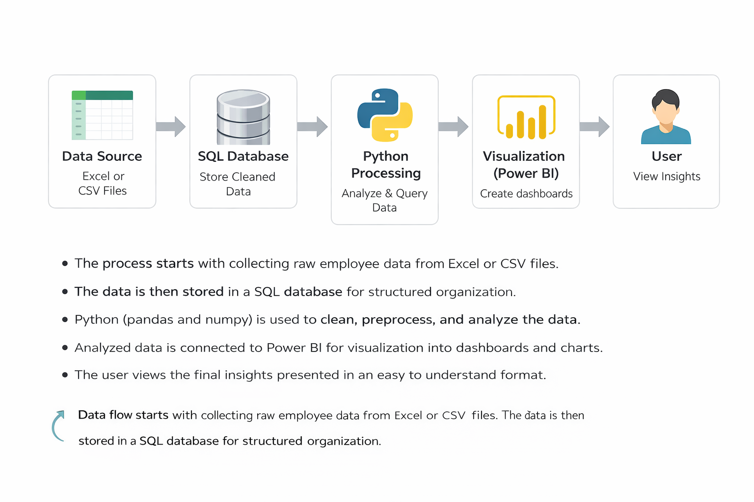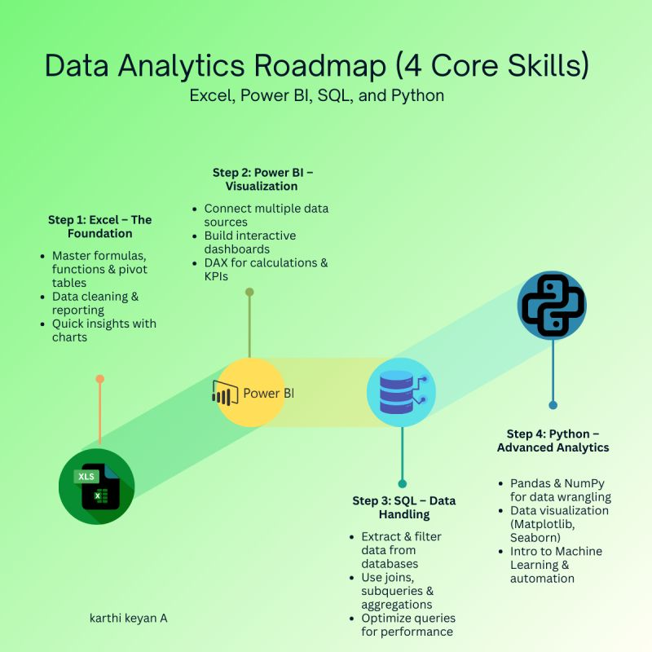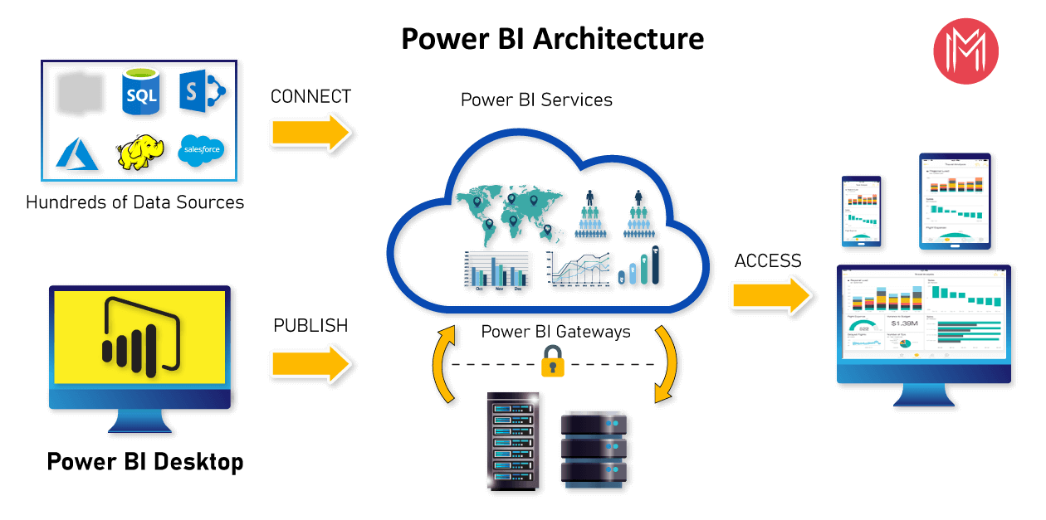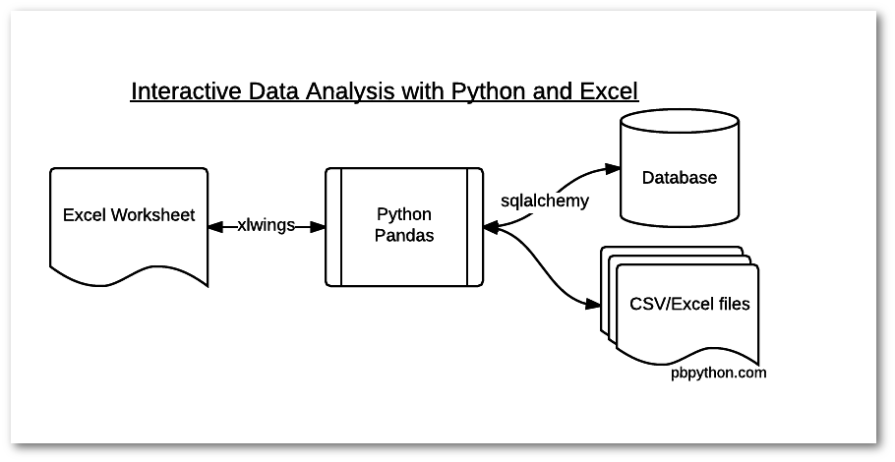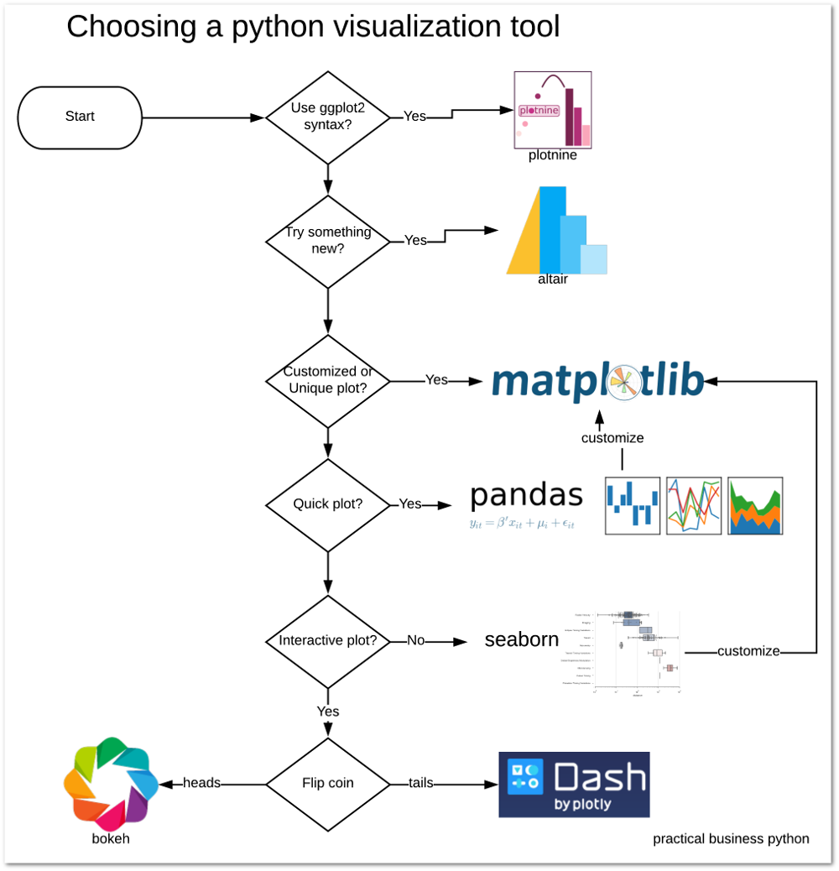
Explanation of each block
Data Source
This is the starting point of the system where raw data is collected. The data includes restaurant details such as names, ratings, votes, cost, and service features. It is usually maintained in a structured file format.
SQL Database
The cleaned and prepared data is stored in a database. This helps in organizing the data in a structured way and allows easy access and retrieval. It handles large volumes of data efficiently and supports querying for analysis.
Python Processing
In this stage, the data is processed and transformed. Operations such as cleaning, formatting, and creating new fields like rating category, cost category, and popularity are performed. This step prepares the data for analysis.
Visualization Power BI
The processed data is then connected to a visualization tool. Charts, graphs, and cards are created to represent the data visually. This helps in understanding trends, patterns, and comparisons easily.
User
The final output is presented to the user. The user interacts with the dashboard, views insights, and understands the patterns in the data. This helps in making observations and decisions based on the analysis.
Step by step data flow
The process begins with collecting raw data from the data source. This data is then cleaned and stored in a structured format inside the database. From there, it is processed to apply necessary transformations and create useful categories. After processing, the data is visualized using charts and dashboards. Finally, the user interacts with these visual outputs to understand the insights clearly.

9. DATA ANALYTICS SECTION
9.1 Overview
Data analytics refers to the process of examining, organizing, and interpreting data to extract meaningful information and identify patterns. It involves working with structured data to understand relationships between different variables and to gain insights that support better understanding of a system. In this project, data analytics plays a central role in transforming raw restaurant data into useful insights related to food delivery trends and customer demand.
The importance of data analytics in this project lies in its ability to convert simple records into meaningful observations. The dataset contains various attributes such as ratings, votes, pricing, and service features. Individually, these values provide limited information, but when analyzed together, they reveal patterns about customer preferences and restaurant performance. Data analytics helps in identifying these patterns and understanding how different factors influence customer behavior.
Through data analytics, the project is able to explore how features such as online ordering and table booking affect customer engagement. It also helps in understanding how ratings and pricing are connected to popularity. By analyzing these relationships, the system provides a clearer picture of what drives customer demand in food delivery services. This makes the data more valuable and useful for interpretation.
Data analytics also improves the organization and clarity of the dataset. By categorizing numerical values into groups such as rating categories and cost levels, the data becomes easier to understand and compare. These transformations allow users to quickly identify trends without needing to examine each individual value. This enhances the overall readability and usability of the data.
There are different types of analytics that are relevant to this project. Descriptive analytics is used to summarize the data and provide an overview of the current situation. It answers questions such as how many restaurants fall into a particular category or what is the average rating. This type of analysis helps in understanding the basic structure of the dataset.
Diagnostic analytics is used to explore relationships between different attributes and understand the reasons behind certain patterns. For example, it helps in analyzing why certain restaurants have higher popularity or how pricing affects customer engagement. This type of analysis provides deeper insights into the data.
Comparative analysis is also applied to compare different groups within the dataset. For instance, restaurants with online ordering can be compared with those without it to observe differences in ratings and votes. This helps in identifying which features contribute more to customer demand.
Trend analysis is used to observe patterns across different categories such as cost levels or restaurant types. It helps in identifying consistent behaviors or variations within the data. This allows for a better understanding of how different factors influence overall demand.
Overall, data analytics in this project serves as the foundation for understanding the dataset. It organizes the data, reveals patterns, and supports meaningful interpretation. By applying different types of analysis, the project is able to provide clear insights into customer demand and restaurant performance in the food delivery domain.

9.2 Data Description
The dataset used in this project consists of structured information related to restaurants and their service features. It is organized in a tabular format where each row represents a single restaurant entry and each column represents a specific attribute associated with that restaurant. The dataset is designed to capture key factors that influence customer demand and food delivery trends.
The primary column in the dataset is the restaurant name, which uniquely identifies each record. This is a text based field and helps in distinguishing one restaurant from another. Along with this, service related columns such as online ordering and table booking indicate whether a restaurant provides these facilities. These fields are categorical in nature and usually contain values such as Yes or No. They play an important role in understanding how service availability affects customer engagement.
The rating column represents the overall customer rating given to a restaurant. This is a numerical field that reflects customer satisfaction based on their experience. Ratings are essential for analyzing how quality perception influences demand. Similarly, the votes column indicates the number of customer responses or interactions. This is also a numerical field and is used to measure popularity and engagement levels of each restaurant.
Another important column in the dataset is the approximate cost for two people. This numerical field provides an estimate of pricing and helps in analyzing affordability. Pricing plays a key role in customer decision making, and this column allows the project to study how cost influences ratings and popularity. The dataset may also include a column representing the type of restaurant or category, which is a categorical field. This helps in comparing different types of restaurants and understanding variations in demand across categories.
In addition to the original columns, the dataset includes derived fields that are created during processing. These include rating category, cost category, and popularity. The rating category groups numerical ratings into levels such as Excellent, Good, or Average. The cost category classifies pricing into segments such as Low, Medium, or High. Popularity is derived based on the number of votes and helps in identifying highly engaged restaurants. These derived fields simplify analysis and make it easier to observe patterns.
The dataset contains a mix of data types, including text, numerical, and categorical values. Text data is used for identifiers such as restaurant names, numerical data is used for ratings, votes, and cost, and categorical data is used for service features and derived categories. This combination of data types allows for a comprehensive analysis of different aspects of restaurant performance.
Each column in the dataset has a specific purpose and contributes to the overall analysis. Service related columns help in understanding convenience factors, numerical columns provide measurable indicators of performance, and categorical columns support grouping and comparison. Together, these attributes enable a detailed examination of how different factors influence customer demand.
The relevance of the dataset lies in its ability to represent real world restaurant scenarios in a structured manner. By capturing key attributes that affect customer decisions, the dataset provides a strong foundation for analysis. It allows the project to explore relationships between different variables and generate insights that reflect actual trends in food delivery services.
Overall, the dataset serves as the core component of the project. It provides the necessary information required for processing, analysis, and visualization. Its structured format and well defined attributes make it suitable for identifying patterns and understanding customer demand in a clear and systematic way.

9.3 Data Preprocessing
Data preprocessing is an important step in the project where raw data is prepared before analysis. The quality of the final results depends on how well the data is cleaned and structured. In this project, preprocessing ensures that the dataset is accurate, consistent, and ready for further analysis. It involves multiple steps such as cleaning, handling missing values, formatting, and creating additional features.
Cleaning of data
The first step in preprocessing is cleaning the dataset. This involves removing unwanted or incorrect data that may affect the analysis. Duplicate records are identified and removed to avoid repetition. Inconsistent entries such as different spellings or variations in categorical values are corrected to maintain uniformity. For example, values like Yes and No are standardized so that they are consistent across all records. Any irrelevant columns that do not contribute to the analysis are also removed to simplify the dataset.
Handling missing values
The dataset may contain missing or incomplete values in certain columns. These missing entries need to be handled carefully to ensure that they do not affect the analysis. Depending on the situation, missing values are either filled or removed. Numerical fields such as ratings or cost may be filled with appropriate values if possible, while records with excessive missing information may be excluded. This step ensures that the dataset remains reliable and does not produce misleading results.
Formatting of data
After cleaning and handling missing values, the data is formatted to ensure consistency in structure. Numerical columns are converted into proper numeric formats so that calculations can be performed accurately. Text fields are standardized to maintain uniform representation. For example, all categorical values are converted into a consistent format to avoid confusion during analysis. Proper formatting also ensures that the data can be easily processed and queried without errors.
Feature engineering
Feature engineering involves creating new columns from the existing data to enhance analysis. In this project, additional fields such as rating category, cost category, and popularity are generated. Rating category groups numerical ratings into meaningful levels such as Excellent, Good, or Average. Cost category classifies pricing into segments such as Low, Medium, or High. Popularity is derived based on the number of votes and helps in identifying highly engaged restaurants. These new features simplify complex data and make it easier to identify patterns and trends.
Overall preprocessing flow
All these steps are performed in a structured manner to ensure that the dataset is clean and ready for analysis. The preprocessing stage transforms raw data into a well organized format, making it suitable for further processing and visualization. By ensuring data quality and consistency, this step plays a key role in improving the accuracy and effectiveness of the overall analysis.

9.4 Exploratory Data Analysis (EDA)
Exploratory Data Analysis is performed to understand the structure of the dataset and to identify patterns, trends, and relationships between different attributes. It helps in gaining an initial understanding of how the data behaves and what kind of insights can be derived from it. In this project, EDA focuses on examining restaurant features, customer ratings, pricing, and engagement levels to understand food delivery trends and customer demand.
One of the primary observations in the dataset is the distribution of restaurant ratings. Most restaurants tend to fall within a moderate to high rating range, indicating that customer satisfaction is generally consistent across the dataset. A smaller number of restaurants have very high or very low ratings, showing that extreme experiences are less common. This distribution helps in understanding the overall quality level of restaurants and how customers perceive them.
The analysis of customer votes reveals patterns related to popularity. Restaurants with higher vote counts are generally more popular and attract more customer attention. It is observed that restaurants with better ratings often receive more votes, suggesting a positive relationship between customer satisfaction and engagement. However, there are also cases where restaurants with moderate ratings have high votes, indicating that factors other than ratings, such as service convenience, may influence customer interest.
When examining pricing, it is clear that most restaurants fall within a mid range cost category. Lower cost restaurants tend to attract a larger number of customers, as they are more accessible to a wider audience. Higher cost restaurants, while fewer in number, may still maintain good ratings but often receive fewer votes compared to moderately priced options. This shows that affordability plays a significant role in influencing customer demand.
Service features such as online ordering and table booking show distinct patterns in the dataset. Restaurants that offer online ordering tend to have higher engagement levels in terms of votes and popularity. This indicates that convenience is a major factor driving customer demand. On the other hand, table booking is more relevant for dine in experiences and does not always show the same level of impact on delivery related engagement. This comparison highlights how different service features influence customer behavior in different ways.
Category based analysis provides further insights into how different types of restaurants perform. Certain categories show higher popularity and better ratings, indicating stronger customer preference. This variation suggests that customer demand is not uniform and depends on the type of service and offerings provided by the restaurant. By grouping restaurants into categories, it becomes easier to compare their performance and identify which types are more successful.
The relationship between rating and cost also reveals important trends. Restaurants that maintain a balance between reasonable pricing and good quality tend to achieve better ratings and higher engagement. Extremely high priced restaurants may not always receive the highest ratings, especially if customer expectations are not met. This indicates that value for money is an important factor in shaping customer perception.
Another important pattern observed is the distribution of popularity across different categories. Highly popular restaurants are not limited to a single category but are spread across different types. However, they often share common characteristics such as good ratings, moderate pricing, and availability of convenient services. This suggests that a combination of factors contributes to customer demand rather than a single attribute.
The analysis also highlights the importance of derived features such as rating category and cost category. These grouped fields make it easier to observe patterns at a broader level. Instead of focusing on individual values, categories help in identifying overall trends and comparing different segments of the dataset. This improves the clarity of analysis and supports better interpretation of results.
Overall, Exploratory Data Analysis provides a detailed understanding of the dataset by revealing key patterns and relationships. It shows how different attributes interact with each other and influence customer demand. By examining distributions, comparisons, and trends, the analysis helps in identifying important factors that drive restaurant performance and customer engagement in food delivery services.

9.5 TOOLS USED
The following tools are used in this project to perform data processing, analysis, storage, and visualization. Each tool plays a specific role in the overall workflow.
1. Python
Python is the core programming tool used for implementing the entire data analysis process. It is used to write scripts for data cleaning, transformation, and analysis.

2. Jupyter Notebook
Jupyter Notebook is used as the development tool where Python code is written and executed. It provides an interactive environment to run code step-by-step and view outputs instantly.

3. Pandas
Pandas is used for data manipulation and handling structured data. It helps in reading datasets, filtering data, grouping values, and creating new columns required for analysis.

4. NumPy
NumPy is used for numerical computations. It supports mathematical operations and helps in handling arrays and performing calculations efficiently.

5. Matplotlib
Matplotlib is used for creating visualizations such as bar charts and histograms. It helps in understanding patterns and trends in the dataset during analysis.

6. MySQL
MySQL is used as the database tool for storing and managing the dataset. It allows execution of SQL queries to retrieve and analyze data efficiently.

7. Microsoft Power BI
Power BI is used as the visualization and reporting tool. It is used to create interactive dashboards, charts, and KPI indicators for better understanding of insights.

Summary
These tools work together to form a complete data analytics pipeline. Python and its libraries handle data processing, MySQL manages data storage, and Power BI provides visualization, making the system efficient and easy to use.

10. SOFTWARE REQUIREMENTS
Software requirements refer to the platforms and environments needed to develop, run, and execute the project. These provide the base setup where all tools and libraries function.
1. Operating System
The project can run on operating systems such as Windows, macOS, or Linux. In this project, a Windows environment is typically used, which supports Python, Jupyter Notebook, and other required tools. The operating system manages file handling, software installation, and execution of programs.

2. Python Environment
Python is required as the core programming language. A proper Python environment must be installed to execute scripts and run data analysis.
In this project:
- Python is used to write all preprocessing and analysis logic
- It acts as the base for libraries like pandas, NumPy, and matplotlib
- Version compatibility is important to ensure smooth execution

3. Jupyter Notebook Environment
Jupyter Notebook is required as the development platform for writing and running code interactively.
In this project:
- It provides an interface to execute Python code step-by-step
- It allows combining code, outputs, and explanations in one place
- It helps in testing and debugging during development

4. Library Support (Python Packages)
The system requires installation of essential Python libraries. These are not standalone software but part of the Python environment.
Required libraries include:
- pandas for data handling
- NumPy for numerical operations
- matplotlib for visualization
These libraries must be installed using package managers such as pip before running the project.

5. Database Software (MySQL)
MySQL is used as the database system for storing and querying structured data.
In this project:
- It stores insurance dataset in table format
- SQL queries are executed to filter and analyze data
- It supports structured data management and retrieval

6. Data Visualization Software (Microsoft Power BI)
Power BI is required for creating dashboards and visual reports.
In this project:
- It connects to processed data
- It is used to build interactive dashboards
- It helps in visualizing insights using charts and KPI cards

7. Web Browser
A web browser such as Chrome or Edge is required to access Jupyter Notebook and Power BI interfaces. It provides the interface for interacting with dashboards and notebooks.

Summary
The software requirements define the environment needed to run the project successfully. Python and Jupyter Notebook provide the development platform, MySQL manages data storage, and Power BI handles visualization. Together, these components create a complete system setup for executing the insurance data analytics project.
11. HARDWARE REQUIREMENTS
1. Processor
- Minimum Intel Core i3 or equivalent
- Recommended Intel Core i5 or higher
The processor is responsible for executing all operations in the system. A basic processor like i3 can handle small datasets and simple analysis. However, for better performance, especially when running multiple tools such as Jupyter Notebook and Power BI together, a higher processor like i5 or above is preferred. A faster processor reduces computation time and improves overall system responsiveness.
2. RAM
- Minimum 4 GB RAM
- Recommended 8 GB or more
RAM is used to temporarily store data during execution. A minimum of 4 GB is sufficient for basic tasks, but it may cause slow performance when handling larger datasets. Using 8 GB or more allows smoother multitasking and faster data processing. Higher RAM ensures that the system does not lag when multiple applications are running.
3. Storage
- Minimum 256 GB storage
- Recommended SSD storage
Storage is required to install software and store datasets and project files. A minimum of 256 GB is needed for proper functioning. Solid State Drives are recommended over traditional hard drives because they provide faster data access and improve system speed. Faster storage reduces loading time and enhances performance.
4. Operating System
- Windows, macOS, or Linux supported
- Recommended 64-bit Windows 10 or above
The operating system acts as the base platform for running all tools and applications. A 64-bit system is recommended for better compatibility and performance. Windows 10 or higher is commonly used as it supports all required software such as Python, MySQL, and Power BI efficiently.
Summary
The hardware components play an important role in ensuring smooth execution of the project. A good processor, sufficient RAM, fast storage, and a compatible operating system together provide a stable and efficient working environment.

Why These Hardware Requirements Are Sufficient for the Project
The specified hardware configuration is sufficient for this project because the nature of the work involves moderate data processing, analysis, and visualization, rather than extremely heavy computations or large-scale distributed systems. Each component supports the project requirements effectively.
Processor Sufficiency
The project mainly uses Python, Jupyter Notebook, SQL queries, and Power BI dashboards. These tasks involve data manipulation, filtering, grouping, and visualization, which do not require very high-end processing power. A processor like Intel Core i3 can handle these operations without major issues. However, using an i5 or higher ensures faster execution when performing multiple operations or running several tools at the same time. Since the dataset is of manageable size and not extremely large, this level of processing power is sufficient.
RAM Sufficiency
The dataset used in this project is structured and moderate in size, meaning it can easily fit into memory. A minimum of 4 GB RAM is enough to load and process such data in pandas and NumPy. However, when using tools like Power BI along with Jupyter Notebook, additional memory is beneficial. With 8 GB RAM, the system can handle multitasking smoothly, ensuring that data analysis, visualization, and querying operations run without lag. Therefore, this RAM range is adequate for efficient performance.
Storage Sufficiency
The project requires storage for datasets, software installations, and output files such as reports and dashboards. The data size is not extremely large, so 256 GB storage is more than enough to accommodate all files. Using SSD storage further improves performance by reducing loading times and speeding up file access. This ensures quick opening of datasets, faster execution of notebooks, and smooth operation of Power BI dashboards.
Operating System Sufficiency
The project tools such as Python, Jupyter Notebook, MySQL, and Power BI are fully compatible with modern operating systems like Windows, macOS, and Linux. A 64-bit operating system ensures better memory utilization and supports all required software efficiently. Windows 10 or above is commonly used and provides a stable environment for running all components without compatibility issues. Therefore, the operating system requirement is sufficient for seamless execution.
Overall Justification
The project does not involve heavy machine learning models, real-time big data processing, or high-performance computing tasks. Instead, it focuses on structured data analysis, visualization, and dashboard creation. The specified hardware is capable of handling these operations efficiently without unnecessary resource usage. It provides a balanced configuration that ensures smooth performance, cost-effectiveness, and practical usability for real-world implementation.

12. METHODOLOGY
The methodology of this project follows a structured and sequential workflow that transforms raw restaurant data into meaningful insights. Each stage in the process is clearly defined to ensure data accuracy, consistency, and effective analysis. The workflow includes data collection, preprocessing, analysis, visualization, and insights generation.
1. Data Collection
The first step in the methodology is collecting the dataset containing restaurant related information. The data is initially gathered in a structured format with attributes such as restaurant name, service features, ratings, votes, pricing, and category type. This data serves as the foundation for the entire project.
The collected data is stored in a tabular format where each row represents a restaurant and each column represents a specific attribute. At this stage, the data may contain inconsistencies or incomplete values, but it provides the base required for further processing. The focus during this step is to ensure that all relevant fields required for analysis are included in the dataset.
2. Data Preprocessing
After data collection, the next step is preprocessing, where the dataset is cleaned and prepared for analysis using pandas in a notebook environment. This step ensures that the data is accurate, consistent, and suitable for further processing.
Cleaning involves removing duplicate records, correcting inconsistent values, and eliminating irrelevant data. Missing values are handled by either filling them with appropriate values or removing incomplete records where necessary. Formatting is applied to ensure that numerical fields such as ratings, votes, and cost are in the correct format, and categorical values are standardized.
Feature engineering is performed to create additional columns such as rating category, cost category, and popularity. These new fields help in simplifying the dataset and improving the analytical capability. Once preprocessing is complete, the cleaned dataset is exported into a structured format for storage.
3. Data Storage and Analysis
The cleaned dataset is then stored in a MySQL database, where it is organized into tables for efficient querying and retrieval. This step ensures that the data can be handled effectively even as it grows in size.
Analysis is primarily performed using SQL queries in MySQL. Different queries are written to extract meaningful information from the dataset. For example, queries are used to identify top rated restaurants, compare customer engagement across different service features, and analyze the relationship between pricing and popularity.
SQL allows for efficient filtering, grouping, and aggregation of data, making it easier to perform detailed analysis. By combining multiple conditions and operations, complex relationships between attributes can be explored. This stage forms the core analytical part of the project.
4. Visualization
Once the analysis is performed, the results are visualized to make them easier to understand. Matplotlib is used in the initial stages to create basic charts that help in exploring patterns and trends during analysis.
The structured dataset is then connected to Power BI for advanced visualization. In Power BI, dashboards are created using charts and cards to represent key metrics such as total restaurants, average ratings, and popularity levels. Different types of visualizations are used to compare categories, observe trends, and highlight important patterns.
The focus is on creating clear and simple visuals that effectively communicate the findings without adding unnecessary complexity. The dashboards allow users to interact with the data and explore different aspects of the analysis.
5. Insights Generation
The final step in the methodology is generating insights from the analyzed and visualized data. This involves interpreting the results and identifying key patterns that explain customer behavior and food delivery trends.
Insights are derived by examining relationships between attributes such as service features, ratings, pricing, and popularity. For example, the analysis may reveal that restaurants offering online ordering receive higher customer engagement or that moderately priced restaurants tend to perform better in terms of ratings.
These insights help in understanding the factors that influence customer demand and restaurant performance. The findings can be used to support decision making and improve service strategies.
Overall, the methodology provides a clear and systematic approach to handling data. It ensures that each stage of the process contributes to building accurate, meaningful, and useful insights from the dataset.

Use Case Diagram
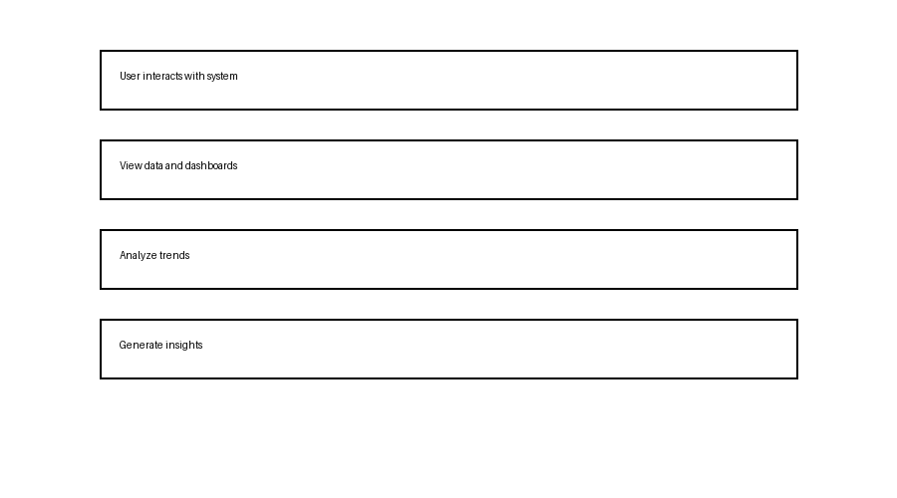
The use case diagram represents how the user interacts with the system. The main actor in this system is the user. The user performs actions such as viewing the dataset, analyzing trends, and observing dashboards. The system responds by processing the data and presenting results in a clear format.
The interaction begins when the user accesses the system. The user can explore restaurant data, view categorized information, and understand patterns through visual outputs. Each action represents a use case where the system provides specific functionality. This diagram helps in understanding the overall functionality of the system from a user perspective.

Class Diagram
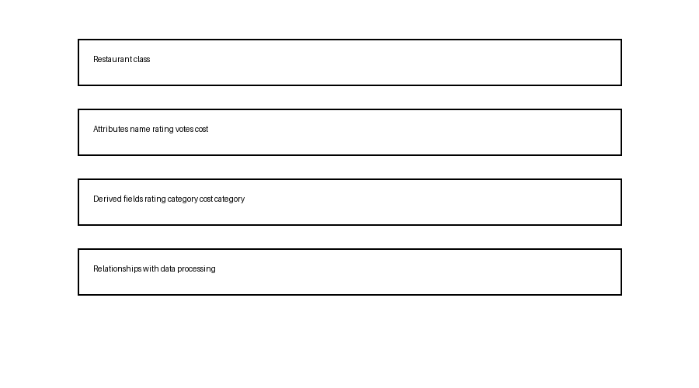
The class diagram represents the structure of the system by showing different classes and their attributes. The main class in this system is the restaurant class, which contains attributes such as name, rating, votes, cost, and service features.
Additional derived attributes such as rating category, cost category, and popularity are included to enhance analysis. These attributes are created during processing and are used for grouping and comparison.
The relationships in the class diagram show how data is connected within the system. The dataset flows through processing stages where new attributes are added, and all fields are used together for analysis. This diagram provides a clear understanding of how the data is organized and structured within the system.

Sequence Diagram
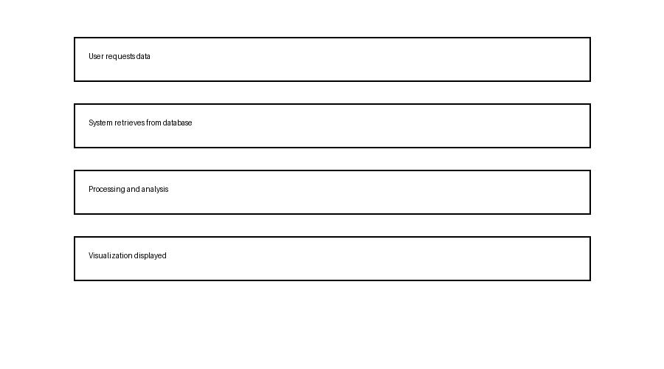
The sequence diagram explains the step by step interaction between the user and the system. It shows how data flows through different stages when a user performs an action.
The process starts when the user requests data or opens the dashboard. The system then retrieves the required data from storage. After retrieval, the data is processed and analyzed to generate meaningful information. Once the processing is complete, the results are displayed in the form of visual outputs.
This sequence shows the order of operations and how each step depends on the previous one. It helps in understanding how the system responds to user actions and how data moves from one stage to another until the final output is presented.
Outputs
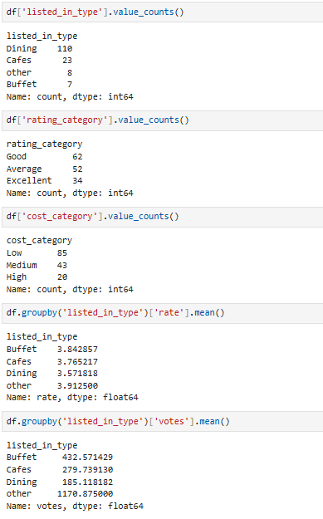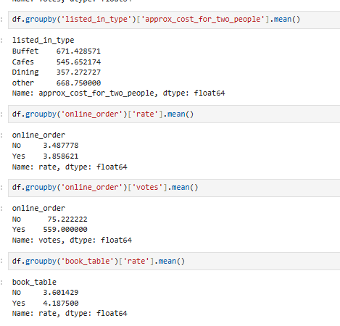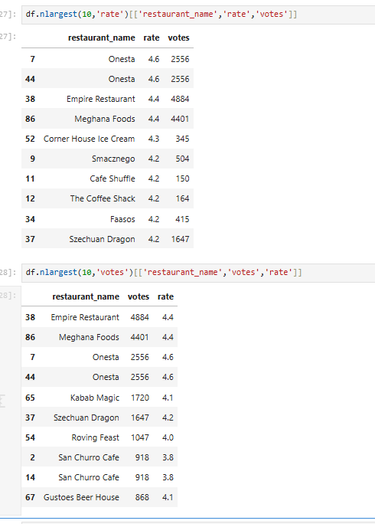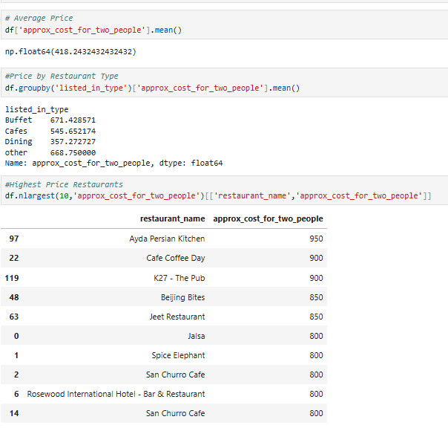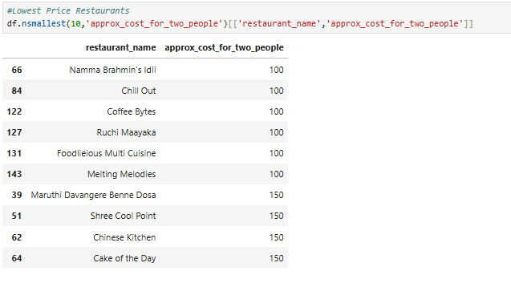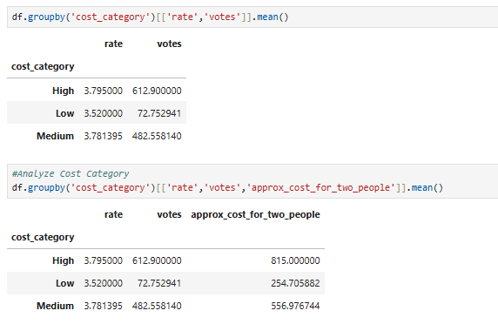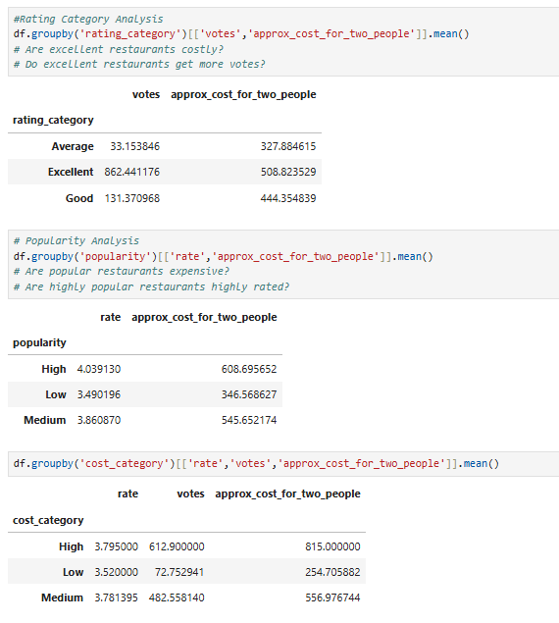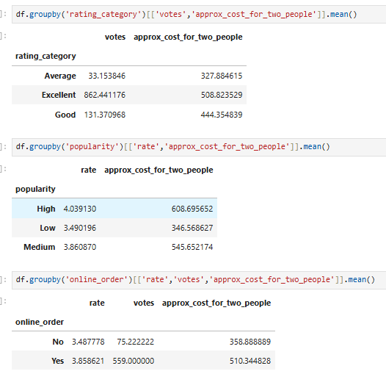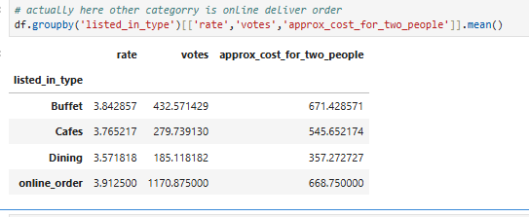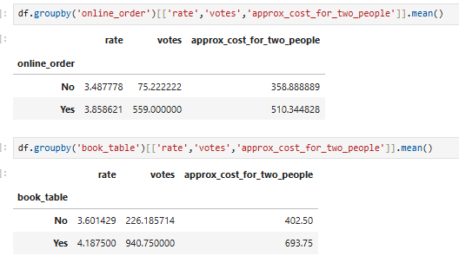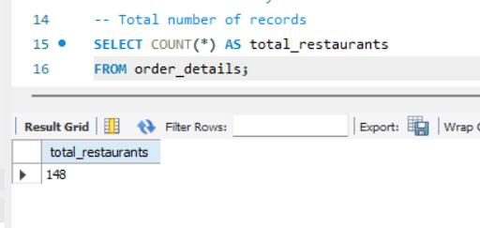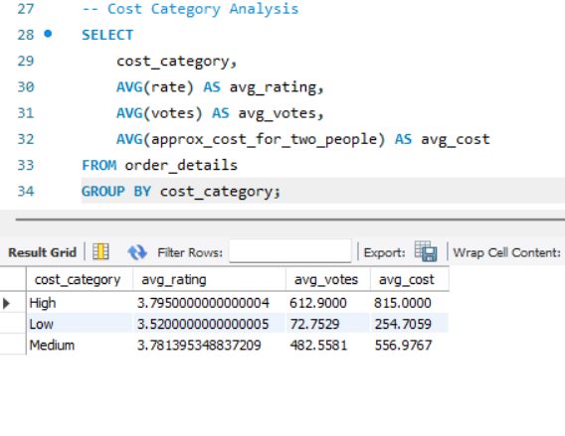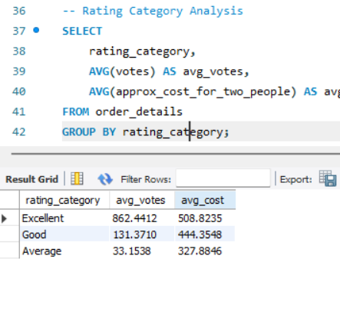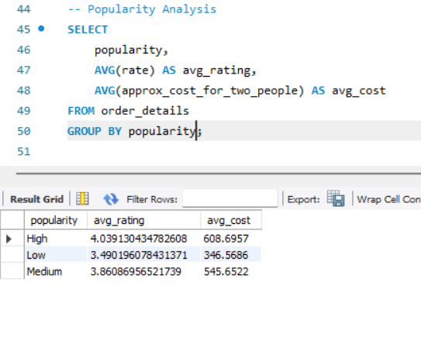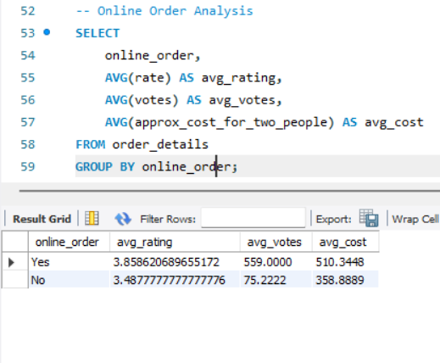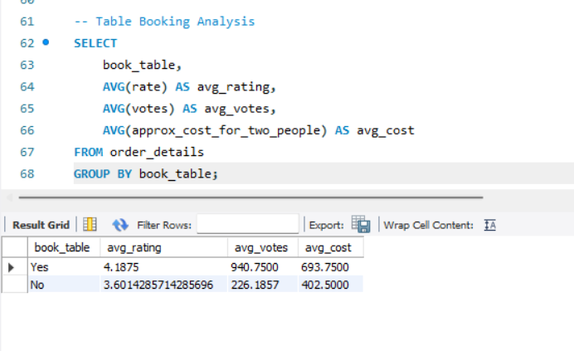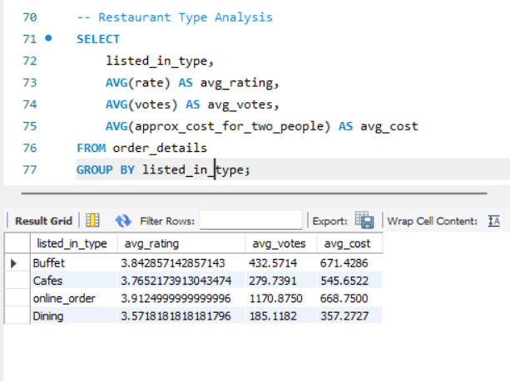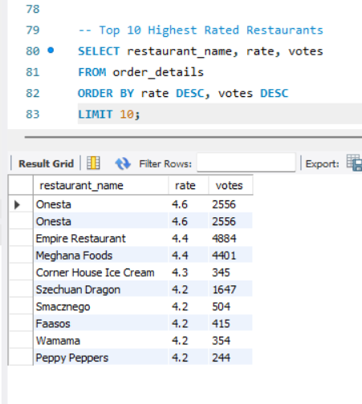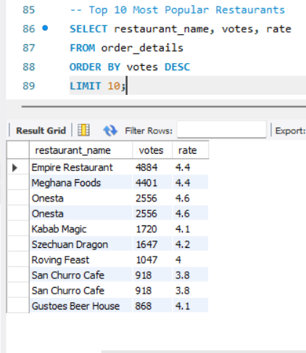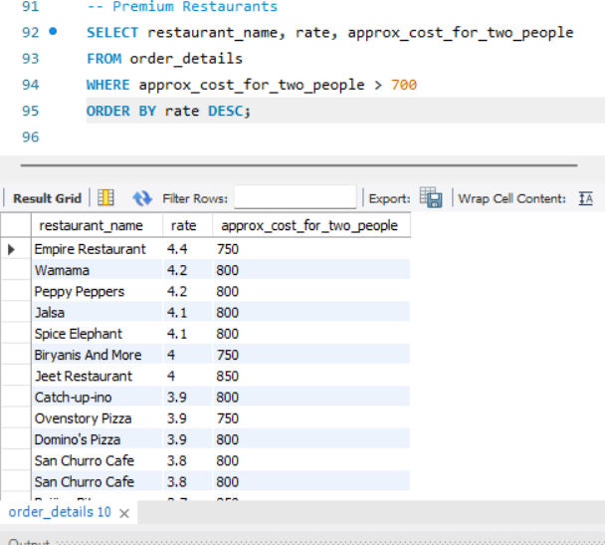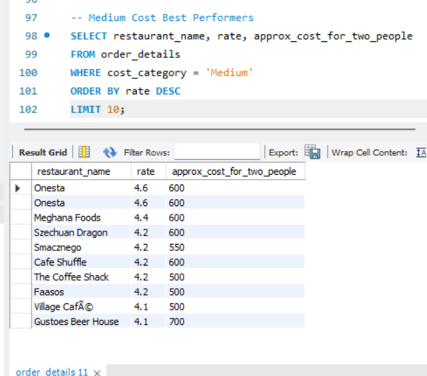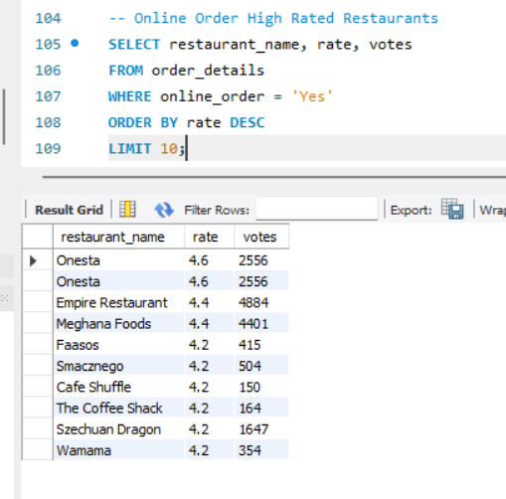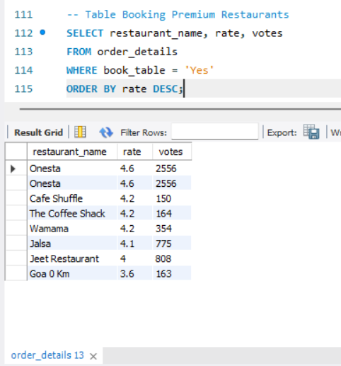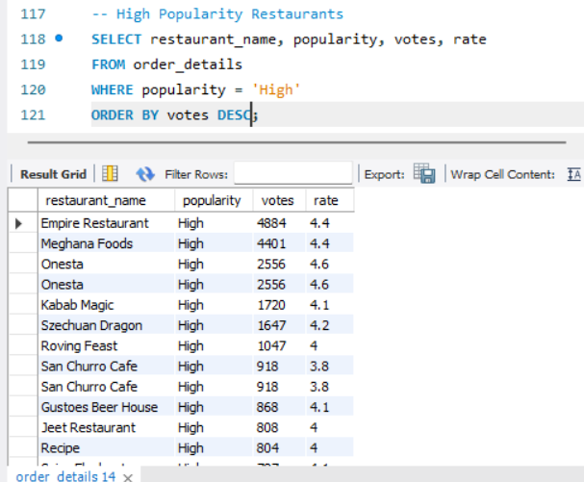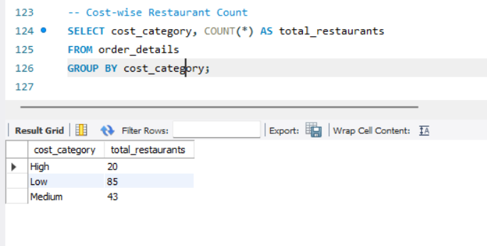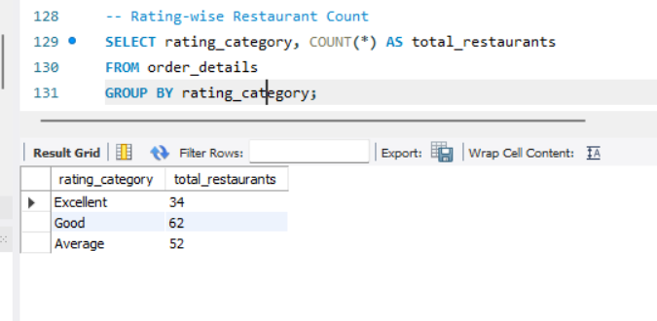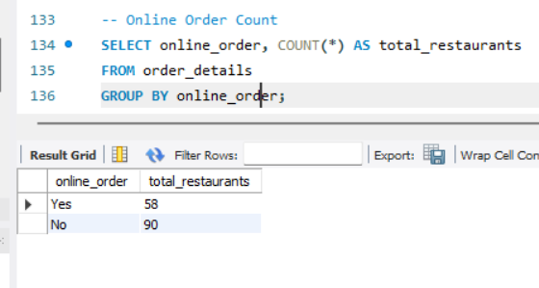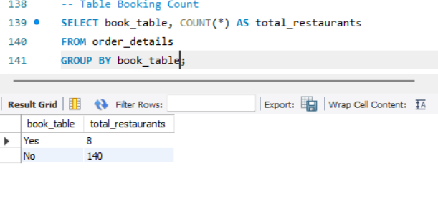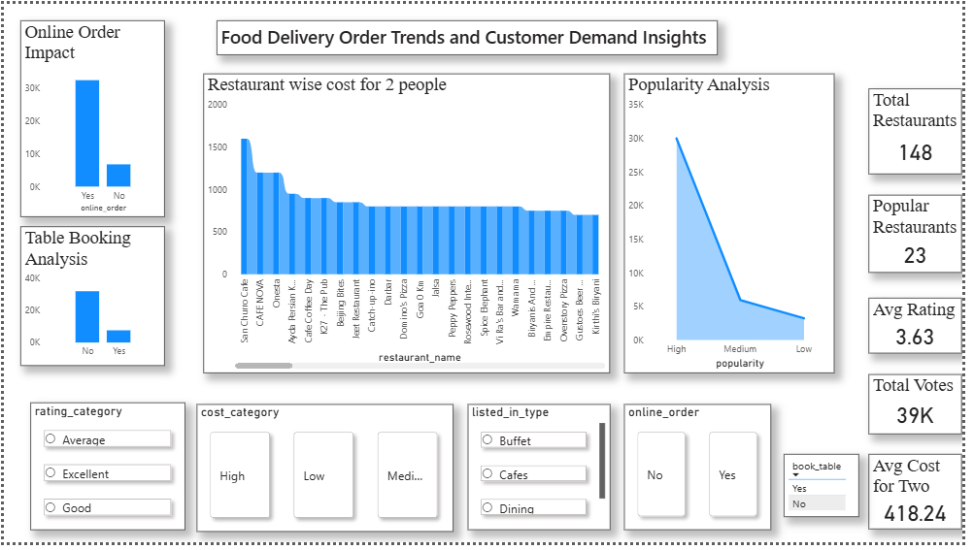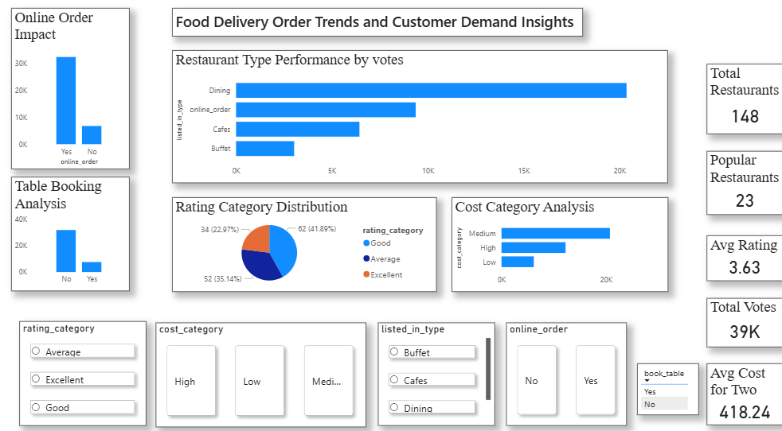

14. OUTPUT AND ANALYSIS
The outputs generated in this project represent different stages of analysis and visualization based on the processed dataset. Each screenshot reflects a specific aspect of the data, highlighting patterns, comparisons, and relationships between various attributes such as ratings, votes, pricing, and service features. The analysis below explains the observations in a descriptive and storytelling manner based on the outputs provided in the document
In the initial output, the dataset is displayed in a structured tabular format after preprocessing. This output shows cleaned and organized data where each column represents a specific attribute such as restaurant name, rating, votes, and cost. The consistency in formatting indicates that preprocessing steps have been successfully applied. From this, it is clear that the data is now ready for analysis. The structured format makes it easier to identify variations in ratings and pricing across different restaurants, forming the foundation for further insights.
Another output focuses on the distribution of restaurant ratings. The visualization shows that most restaurants fall within a mid to high rating range, indicating that customer satisfaction is generally stable. Very few restaurants have extremely low or extremely high ratings, which suggests that the majority of services maintain a consistent quality level. This pattern highlights that customer expectations are being met to a reasonable extent across most entries.
In the output related to customer votes, a noticeable variation in engagement levels can be observed. Some restaurants receive significantly higher votes compared to others. This indicates that certain restaurants are more popular and attract more customer interaction. A pattern emerges where restaurants with higher ratings often tend to have higher votes, showing a connection between quality and popularity. However, there are also cases where moderate ratings still have high votes, suggesting that factors like convenience and availability also influence customer engagement.
The pricing analysis output shows how restaurants are distributed across different cost categories. A majority of restaurants fall into a medium cost range, while fewer are in the low or high cost segments. This indicates that most restaurants aim to maintain a balance between affordability and service quality. The trend suggests that moderately priced restaurants attract a wider audience, as they are accessible to a larger group of customers.
Another important output highlights the comparison between service features such as online ordering and table booking. The visualization clearly shows that restaurants offering online ordering tend to have higher customer engagement. This is evident through higher vote counts and better overall performance. On the other hand, table booking does not show the same level of impact on engagement, indicating that customers prefer convenience in ordering rather than traditional dining arrangements. This pattern strongly reflects the shift towards delivery based services.
The output related to category based analysis shows how different types of restaurants perform. Some categories stand out with higher ratings and popularity, while others show moderate performance. This variation indicates that customer preferences differ based on the type of service or cuisine offered. It becomes clear that certain categories naturally attract more demand, which can be linked to customer taste and convenience.
In the visualization comparing rating and cost, an interesting trend can be observed. Restaurants with moderate pricing often achieve better ratings and higher engagement compared to those with very high pricing. This suggests that customers value affordability along with quality. High priced restaurants may not always meet customer expectations, which affects their ratings. This insight highlights the importance of maintaining a balance between price and service quality.
The outputs that include derived fields such as rating category and cost category provide a clearer view of the data. Instead of focusing on individual values, grouping the data into categories makes it easier to identify trends. For example, a large number of restaurants may fall under good or very good rating categories, which simplifies the understanding of overall performance. This categorization enhances readability and supports better comparison across different groups.
In the final dashboard outputs, key metrics are presented using cards and charts. These visuals provide a summary of important information such as total number of restaurants, average ratings, and distribution of categories. The dashboard allows users to quickly grasp the overall trends without going through detailed data. It also enables comparison between different attributes, making it easier to identify patterns and relationships.
Overall, the outputs collectively show how raw data is transformed into meaningful insights. The patterns observed across different visualizations highlight the importance of service features, pricing, and ratings in influencing customer demand. The analysis clearly indicates that convenience, affordability, and quality are the main factors that drive engagement in food delivery services.

15. OVERALL CONCLUSION
The project provides a comprehensive understanding of food delivery trends and customer demand by systematically analyzing restaurant related data. Through structured data processing and detailed analysis, the study successfully transforms raw data into meaningful insights that reflect real world customer behavior. The outputs generated throughout the project clearly demonstrate how different factors such as service features, ratings, pricing, and customer engagement contribute to overall restaurant performance.
One of the key findings of the analysis is the strong influence of convenience on customer demand. Restaurants that offer online ordering consistently show higher levels of customer engagement and popularity. This indicates that customers prefer quick and accessible services over traditional methods. The shift towards delivery based services highlights the growing importance of convenience in modern food consumption patterns.
Another important observation is the relationship between ratings and customer engagement. Restaurants with higher ratings generally receive more votes, suggesting that customer satisfaction plays a major role in attracting more customers. However, the analysis also shows that ratings alone do not determine popularity. Other factors such as pricing and service availability also contribute to customer interest, making demand a result of multiple combined factors.
Pricing analysis reveals that moderately priced restaurants tend to perform better in terms of both ratings and popularity. These restaurants are able to maintain a balance between affordability and quality, making them more attractive to a wider audience. On the other hand, very high priced restaurants may not always achieve the same level of engagement, indicating that customers are sensitive to value for money.
The use of categorized fields such as rating category and cost category simplifies the understanding of complex data. These groupings make it easier to identify overall trends and compare different segments of the dataset. The analysis of these categories shows that most restaurants fall within average to good performance levels, indicating a generally stable market with consistent service quality.
From a system perspective, the project demonstrates the effectiveness of a structured approach to data handling. The transition from raw data to cleaned and organized data ensures accuracy and consistency. The use of querying for analysis enables efficient extraction of information, while visualization helps in presenting the results in a clear and understandable format. This workflow improves both the efficiency and reliability of the analysis process.
The benefits of this project extend to both understanding and application. It provides valuable insights into customer preferences and restaurant performance, which can be useful for decision making. Restaurants can use these findings to improve their services, adjust pricing strategies, and focus on features that attract more customers. The project also highlights the importance of data driven approaches in analyzing real world problems.
In terms of learning outcomes, the project offers practical experience in handling data through different stages, including preprocessing, analysis, and visualization. It demonstrates how structured data can be used to uncover patterns and relationships that are not immediately visible. The process of working with data, applying logical transformations, and interpreting results enhances analytical thinking and problem solving skills.
The project also emphasizes the importance of organizing data effectively before analysis. Proper preprocessing ensures that the results are accurate and meaningful. The ability to create derived fields and categorize data adds depth to the analysis and improves clarity. Visualization further enhances understanding by presenting complex information in a simple format.
Overall, the project successfully achieves its objective of analyzing food delivery trends and customer demand. It provides a clear understanding of how different factors influence customer behavior and highlights the importance of convenience, affordability, and service quality. The structured methodology and detailed analysis make the findings reliable and applicable in real world scenarios, demonstrating the value of data analytics in understanding and improving business performance.

